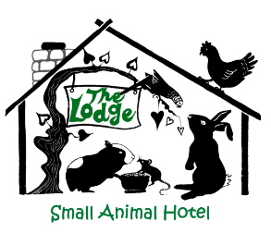
Name of  Animal(s) |  |  |  | Male Female
Type/Breed of  Animal |  |  |  | Age
Owner’s Name
Address and Postcode
Email Address
Contact Tel. Number(s) | Home |  |  | Mobile
Emergency Contact | Name |  |  | Tel. Number
Vets Contact Details | Name and Address |  |  | Telephone Number
Any Previous Medical Conditions
Feeding Details/
Any Other Information
RABBITS ONLY  Vaccinations |  | Combination Myxo/ RVHD1 Vaccine (Nobivac)  Date Given | RVHD2 Vaccine (Filavac or Eravac)  Date Given

Permission to use Photos of Pets on Facebook Page YES NO

By signing below I agree:-

With The Lodge Small Animal Hotel Terms and Conditions

To you using my personal data in line with your privacy policy

I give consent for Rebecca Collins to get any Medical Treatment necessary for my pet if required during their stay but understand I am liable for any costs to be paid

Signed…………………………………………… Date………………………

